**Build & Release Debug logs：**

Hi XXX,

To investigate this issue further, would you mind helping collect Build/Release logs from your side and share the logs with us?

For the files you shared with us, they will be deleted after 90 days when the ticket is closed. If you don’t want to keep them for such a time, you can also delete it by yourself. For more details about the data usage, please check this link for details: [Microsoft Privacy Statement](https://privacy.microsoft.com/en-US/privacystatement).

The logs are necessary for us to go to the next step for this issue. If you still have concerns to share the logs here, we recommend you create a technical support ticket from Azure Portal if you have [Azure support plans](https://azure.microsoft.com/en-us/support/plans/). Thanks for your understanding.

The logs would contain the information below which will help us understand what happened in the issue.

* Detailed environment variables loaded when the build agent run.
* Settings for the tasks in the build/release.
* The customer variables you defined in the build/release definition.
* Actions that the build/release is trying to run.
* Detailed error message when the build/release failed.

If you have some username/password/private information defined as normal variables, please remove it from the logs before sharing it with us. You don’t need to worry about secret variables since we won’t be able to see the value of them.

To get the complete debug logs, please add the variable “**system.debug”** and set the value to “**true”** in your pipeline. After that trigger a new build/release to capture and share the complete logs.

When you share the logs to us, please set it to “**Microsoft Only**” or “**Private to customer (includes Microsoft)**”, this will make sure that the information can be only accessed by us.

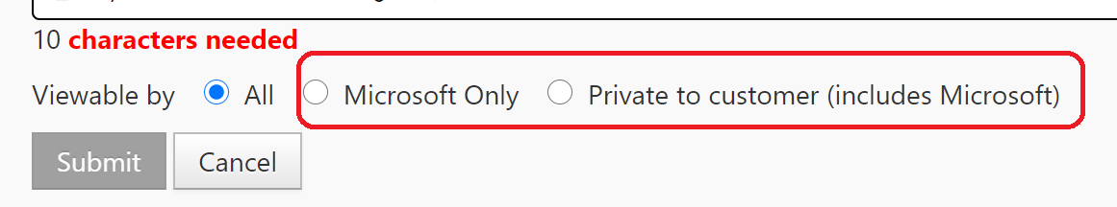

**Fiddler Trace**

*Note: For Fiddler Trace, Please ask the customer to set the filter accordingly based on different issues and ask the customer to remove PII information if the issue was not related to permission/access/sign-in.*

**Below templates for your reference:**

Fiddler Trace: Track for all process (**permission/access/sign-in case**).

Hi XXX,

To investigate this issue further, would you mind helping collect Fiddler logs from your side and share the logs with us?

For the files you shared with us, they will be deleted after 90 days when the ticket is closed. If you don’t want to keep them for such a time, you can also delete it by yourself. For more details about the data usage, please check this link for details: [Microsoft Privacy Statement](https://privacy.microsoft.com/en-US/privacystatement).

The logs are necessary for us to go to the next step for this issue. If you still have concerns to share the logs here, we recommend you create a technical support ticket from Azure Portal if you have [Azure support plans](https://azure.microsoft.com/en-us/support/plans/). Thanks for your understanding.

The logs would contain the information below which will help us understand what happened in the issue.

* The request sent to our service when the issue occurs.
* The response from our service when the issue occurs.
* Identity you used to access our service (For permission/access/sign-in issues).
* Activity ID which we can use to query product trace.

Please follow below steps to generate the fiddler trace file (see [Configure Fiddler to Decrypt HTTPS Traffic](https://docs.telerik.com/fiddler/Configure-Fiddler/Tasks/DecryptHTTPS) for details)

1. Download and install Fiddler (Fiddler Classic)：<http://www.telerik.com/download/fiddler>
2. Launch your fiddler and choose “**Tools**” -> “**Clean Wininet cache**”, then go to “**Tools”** menu -> “**Options**” -> **HTTPS** tab  -> enable “**Decrypt HTTPS Traffic”** ->select **“…from all processes”** in the dropdown list, then close the fiddler.
3. Launch and minimize Fiddler to tray, then replicate the reported issue.
4. In Fiddler, go to File -> Save -> All Sessions and save the archive to disk.

This will produce a **SAZ** file, which you will be able to archive and share with us. Please remove other personal sensitive information except the ones which related to your current account login/permission issue from the SAZ file before sharing it with us.

When you share the logs to us, please set it to “**Microsoft Only**” or “**Private to customer (includes Microsoft)**”, this will make sure that the information can be only accessed by us.



**Fiddler Trace: Track for all process (the issue was not related to permission/access/sign-in).**

Hi XXX,

To investigate this issue further, would you mind helping collect Fiddler logs from your side and share the logs with us?

For the files you shared with us, they will be deleted after 90 days when the ticket is closed. If you don’t want to keep them for such a time, you can also delete it by yourself. For more details about the data usage, please check this link for details: [Microsoft Privacy Statement](https://privacy.microsoft.com/en-US/privacystatement).

The logs are necessary for us to go to the next step for this issue. If you still have concerns to share the logs here, we recommend you create a technical support ticket from Azure Portal if you have [Azure support plans](https://azure.microsoft.com/en-us/support/plans/). Thanks for your understanding.

The logs would contain the information below which will help us understand what happened in the issue.

* The request sent to our service when the issue occurs.
* The response from our service when the issue occurs.
* Identity you used to access our service (For permission/access/sign-in issues).
* Activity ID which we can use to query product trace.

Please follow below steps to generate the fiddler trace file (see [Configure Fiddler to Decrypt HTTPS Traffic](https://docs.telerik.com/fiddler/Configure-Fiddler/Tasks/DecryptHTTPS) for details)

1. Download and install Fiddler (Fiddler Classic)：<http://www.telerik.com/download/fiddler>
2. Launch your fiddler and choose “**Tools**” -> “**Clean Wininet cache**”, then go to “**Tools”** menu -> “**Options**” -> **HTTPS** tab  -> enable “**Decrypt HTTPS Traffic”** ->select **“…from all processes”** in the dropdown list, then close the fiddler.
3. Launch and minimize Fiddler to tray, then replicate the reported issue.
4. In Fiddler, go to File -> Save -> All Sessions and save the archive to disk.

This will produce a **SAZ** file, which you will be able to archive and share with us. Please remove all personal sensitive information (username/password/token etc) from the SAZ file before sharing it with us.

When you share the logs to us, please set it to “**Microsoft Only**” or “**Private to customer (includes Microsoft)**”, this will make sure that the information can be only accessed by us.



**Fiddler Trace: Track for the specific hosts**

Hi XXX,

To investigate this issue further, would you mind helping collect Fiddler logs from your side and share the logs with us?

For the files you shared with us, they will be deleted after 90 days when the ticket is closed. If you don’t want to keep them for such a time, you can also delete it by yourself. For more details about the data usage, please check this link for details: [Microsoft Privacy Statement](https://privacy.microsoft.com/en-US/privacystatement).

The logs are necessary for us to go to the next step for this issue. If you still have concerns to share the logs here, we recommend you create a technical support ticket from Azure Portal if you have [Azure support plans](https://azure.microsoft.com/en-us/support/plans/). Thanks for your understanding.

The logs would contain the information below which will help us understand what happened in the issue.

* The request sent to our service when the issue occurs.
* The response from our service when the issue occurs.
* Identity you used to access our service (For permission/access/sign-in issues).
* Activity ID which we can use to query product trace.

Please follow below steps to generate the fiddler trace file (see [Configure Fiddler to Decrypt HTTPS Traffic](https://docs.telerik.com/fiddler/Configure-Fiddler/Tasks/DecryptHTTPS) for details)

1. Download and install Fiddler (Fiddler Classic)：<http://www.telerik.com/download/fiddler>
2. Launch your fiddler and choose “**Tools**” -> “**Clean Wininet cache**”, then go to “**Tools”** menu -> “**Options**” -> **HTTPS** tab  -> enable “**Decrypt HTTPS Traffic”** ->select **“…from all processes”** in the dropdown list.
3. Go to **Filters** -> Select “**Use Filters**” -> Set the filters (e.g **Show only the following Hosts** -> dev.azure.com) -> “**Actions**” -> **“Run Filterset now”,** then close the fiddler.
4. Launch and minimize Fiddler to tray, then replicate the reported issue.
5. In Fiddler, go to File -> Save -> All Sessions and save the archive to disk.

This will produce a **SAZ** file, which you will be able to archive and share with us. Please remove personal sensitive information from the SAZ file and share it in private channel (Microsoft Only), this will make sure that the information can be only accessed by us.

Filter by Hosts:

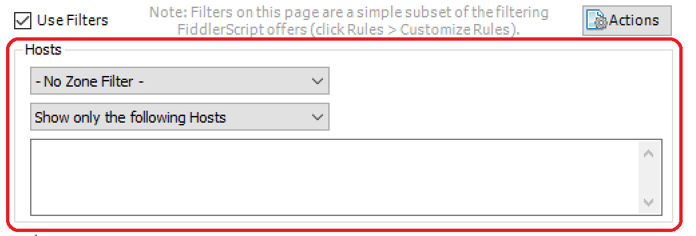



**Fiddler Trace: Track for the specific client process**

Hi XXX,

To investigate this issue further, would you mind helping collect Fiddler logs from your side and share the logs with us?

For the files you shared with us, they will be deleted after 90 days when the ticket is closed. If you don’t want to keep them for such a time, you can also delete it by yourself. For more details about the data usage, please check this link for details: [Microsoft Privacy Statement](https://privacy.microsoft.com/en-US/privacystatement).

The logs are necessary for us to go to the next step for this issue. If you still have concerns to share the logs here, we recommend you create a technical support ticket from Azure Portal if you have [Azure support plans](https://azure.microsoft.com/en-us/support/plans/). Thanks for your understanding.

The logs would contain the information below which will help us understand what happened in the issue.

* The request sent to our service when the issue occurs.
* The response from our service when the issue occurs.
* Identity you used to access our service (For permission/access/sign-in issues).
* Activity ID which we can use to query product trace.

Please follow below steps to generate the fiddler trace file (see [Configure Fiddler to Decrypt HTTPS Traffic](https://docs.telerik.com/fiddler/Configure-Fiddler/Tasks/DecryptHTTPS) for details)

1. Download and install Fiddler (Fiddler Classic)：<http://www.telerik.com/download/fiddler>
2. Launch your fiddler and choose “**Tools**” -> “**Clean Wininet cache**”, then go to “**Tools”** menu -> “**Options**” -> **HTTPS** tab  -> enable “**Decrypt HTTPS Traffic”** ->select **“…from all processes”** in the dropdown list.
3. Go to **Filters** -> Select “**Use Filters**” -> “**Client Process”** -> “**Show only traffic from”,** select the specific client process -> “**Actions**” -> **“Run Filterset now”** , then close the fiddler.
4. Launch and minimize Fiddler to tray, then replicate the reported issue.
5. In Fiddler, go to File -> Save -> All Sessions and save the archive to disk.

Filter by Process:

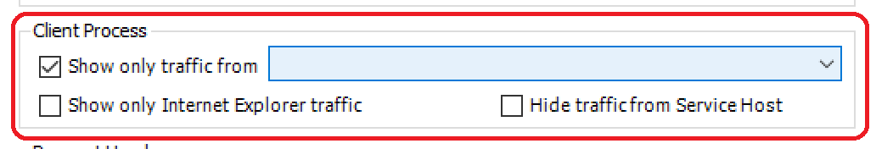

This will produce a SAZ file, which you will be able to archive and share with us. Please remove personal sensitive information from the SAZ file and share it in private channel (Microsoft Only), this will make sure that the information can be only accessed by us.

